Posted 09/13/12 at 2:30 pm by JAV

Town Hall Building Committee

DRAFT Agenda
Fireplace Room, Old Library
Thursday, September 20, 2012
8:00 AM

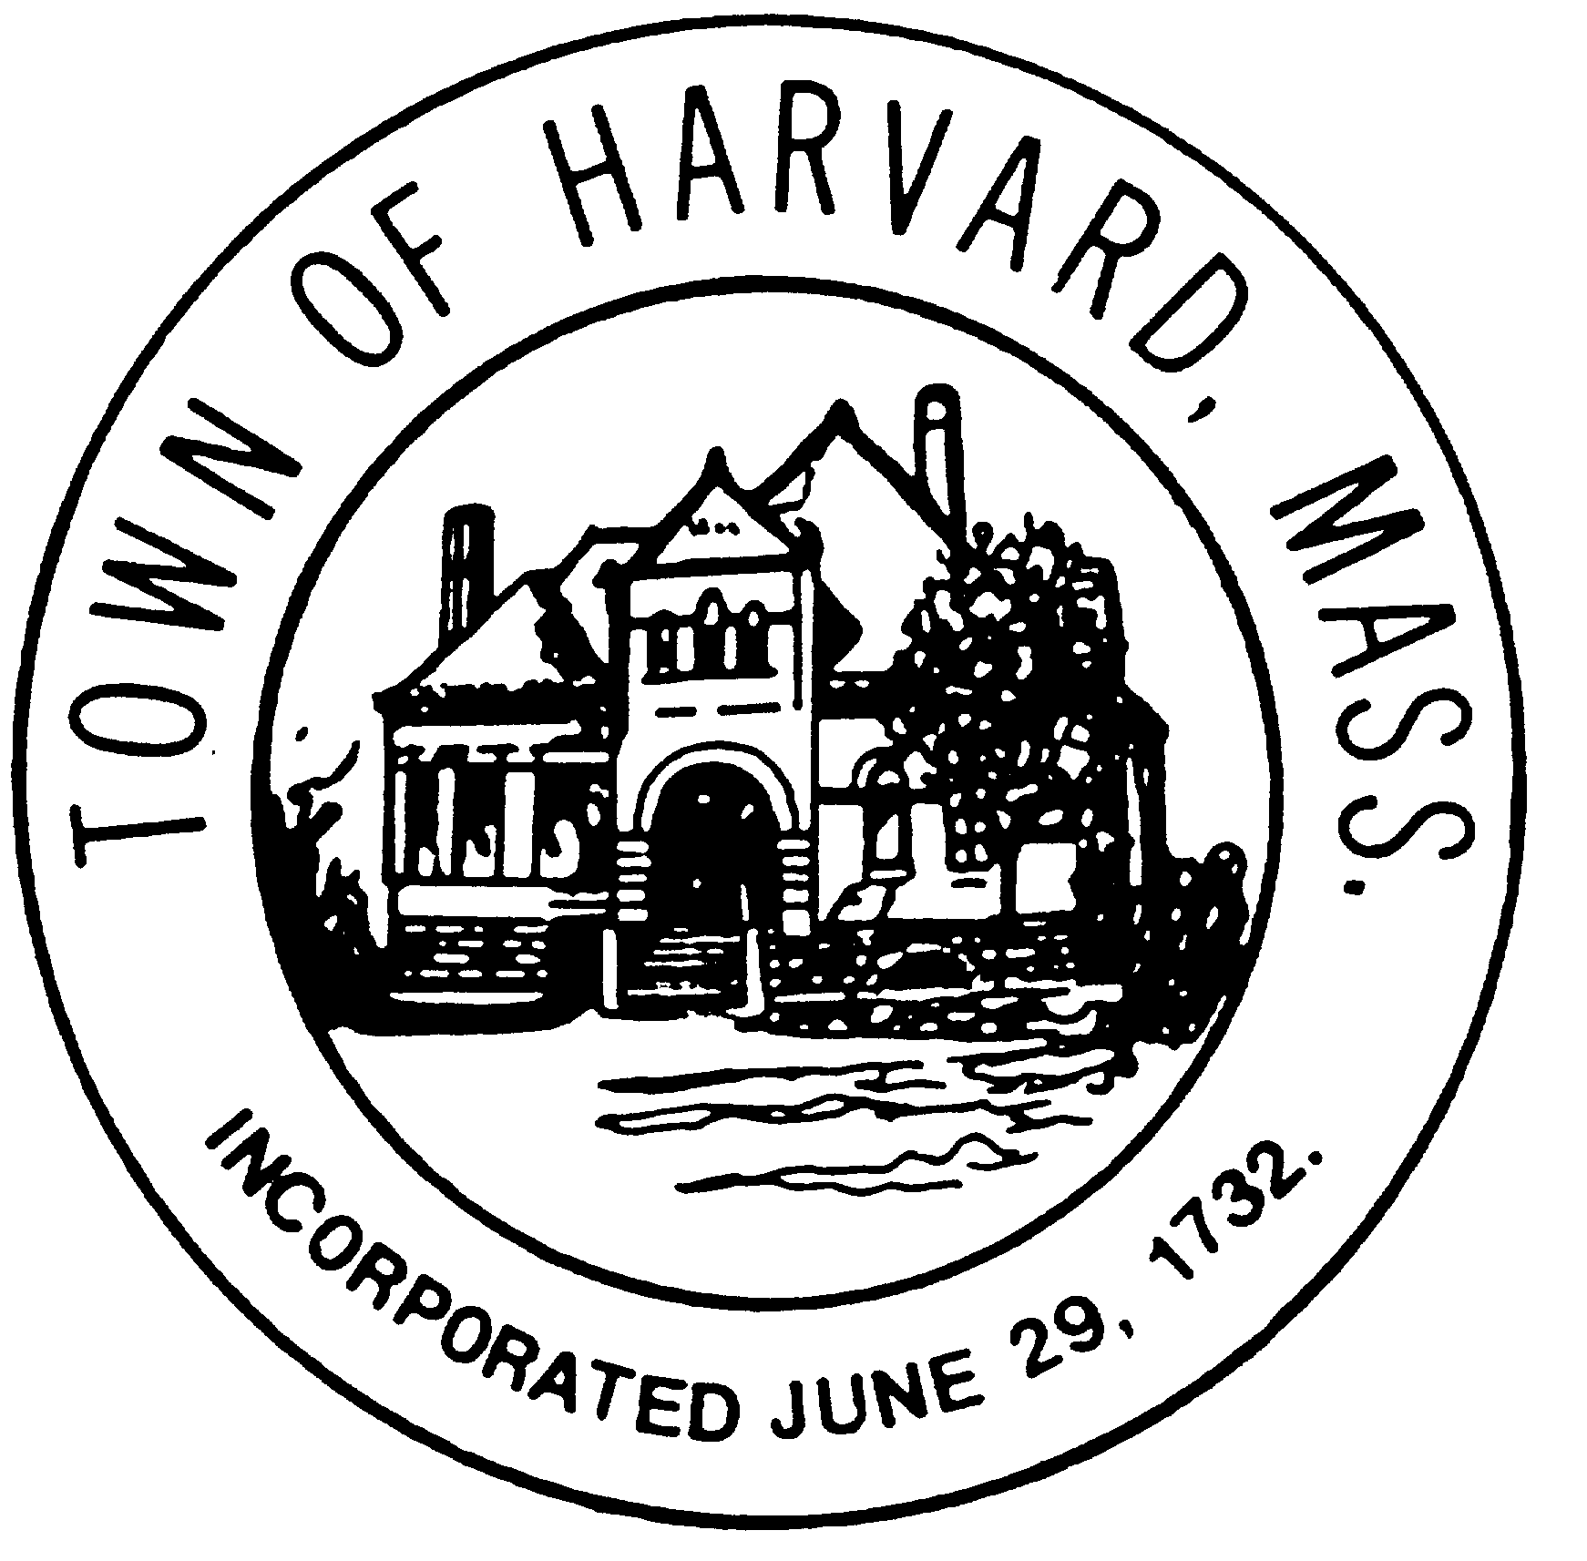
- Public Comment

- Approve minutes

- Approve invoices

- Strategy for applying for variances

- Agenda and date for next meeting(s)

- New business

